Mount Everest Case Study.
Name.
Institution.
Date.

Mount Everest Case Study
Question 1
People have different reasons for ascending on mountain tops. Some people have the desire to reach the peak of the mountain to set history while others climb for monetary purposes. As a result, people who have less knowledge on mountain climbing depends on experienced mountain climbers to help them climbing to the peak. In the Mount Everest – 1996 case study, Scott Fischer launched Mountain Madness Company that trained clients by offering instructions and guided expeditions (Roberto & Carioggia, 2006). To successfully reach the ultimate destination, climbers must have the ability to acclimatize; the ability of an individual to adapt when in a new environment. This implies that amateurs have to learn under the leadership of professional climbers and learn acclimatization techniques. In the case in question, Fischer incorporated two leaders: Boukreev and Beidleman. The analysis of the Fischer and Boukreev, who had successfully climbed several mountains, provides a general idea of the personal traits needed. The first trait apparent in all the leaders is ambitiousness. According to Roberto & Carioggia, before the foundation of the Mountain Madness Company, Fischer was known for his courageous exploits. In addition, he was popular for his charismatic character coupled by the immense of desire for respect. The most interesting trait I admired is Boukreev’s. According to the case study, Boukreev was among the most experienced high altitude climbers as exemplified by the number of mountains he had successfully climbed; however, he did not disregard the dangers associated with mountain climbing. In my opinion, climbing expeditions are normal behaviors taken to an extreme. I can compare them to local businesses who decide to go global where they are faced with different aspects such as customer cultures and legal implications (Lewis, 2017). By conducting prior research, businesses will understand the external market and operate efficiently. Likewise, mountain climbers who train well and understand the dangers inherent in climbing the mountains will successfully reach the peak. Therefore, comparing mountains climbers to a local business going global, I can comfortably assert that mountain climbing is just a normal human behavior taken to the extreme.
Question 2
Going by statistics, eight people died in the storm including expedition leaders and a guide marking 1996 as the Mount Everest’s most disastrous year. There are many conflicting opinions on the actual root cause of the tragedy and the most common being that the roots of the1996 tragedy were the overcrowding of the upper mountain and the commercial competition on mountain climbing. However, in Roberto’s article, it is apparent that guides had warned of the possible threats as expressed in his assertion that in climbing a mountain, an individual ought not to make any mistake (Rpberto & Carioggia, 2006). In addition, he argued that climbers’ favorable weather coupled with good luck. Boukreev’s assertion is a proof that the climbers understood all the dangers attributed with the mountain climbing. On the other hand, on a leadership perspective, cognitive biases inherent in Fischer and Hall’s decision making abilities that contributed to the Everest catastrophe (Meschiti, 2018). The two leaders, Fischer and Hall, had successfully led other expeditions. Viewing the tragedy on individual, group and organizational system lens reveals leadership mistakes of the 1996 Mountain Madness expedition. Fischer and Scott, organizational leaders, were carried away by the recency-effect limitations. According to Roberto & Carioggia, the two professional climbers had successfully led many expeditions. In 1996 climb, the two leaders assumed that weather would be calm like the recent climbs; they were historical biased since they used the recent weather as a norm while I real sense it was an outlier (Shwarz, 2013). On the other hand, the guides in the groups were very specific and helped the individual group members to understand all the problems, a good move to perform the overconfidence bias. Finally, on an individual focus, people who were carried away by the sunk-cost effect died in the historical catastrophe. For instance, Hansen who, was in Hall’s team, was committed to reaching the peak of Mount Everest despite the storm. While other climbers decided to climb down in darkness, Hansen reached the peak but died before descending. Therefore, the Mount Everest tragedy can be attributed to cognitive leadership biases.
Question 3
In my view, tragedies like the 1996 Mount Everest disaster can be either avoidable. Overcoming such tragedies is a question of leadership in extreme contexts. According to the history of these tragedies, it is apparent, depending on the cognitive thinking of an individual in order to overcome such situations, biased decision making should me utterly shunned. In Roberto article, he discusses the effects of the sunk-cost effect, recency effect, and the overconfident bias (Roberto & Carioggia, 2006). These factors can sometimes be crucial push factors to success, but on the other hand can be the killers of success and consequently predisposing people to negative ramifications such as death or life threatening injuries. This approach also applies to novices (followers). In my opinion, a leader who avoids any situation beyond his control, that might predispose employees or followers, is an effective leader who is ready to protect his organization or followers from massive failures or historical tragedies like the Mount Everest tragedy. Second, despite the knowledge that confidence is a critical factor in leadership, overconfidence can detriment the leadership abilities. Leaders who can analyze situations and avoid making decisions based on recent achievements can avoid previous mistakes. Likewise, leaders who avoid anchoring on past events (recency-effect) are highly likely to overcome complex situations. Personally, I believe that the leaders of the 1996 expedition would have averted the situation if they had overcome cognitively biased decision making. Therefore, with appropriated decision making, it is possible to prevent tragedies such as the historical Mt Everest tragedy.
Question 4
Many factors hindered the followers from offering their dissent opinions in the preparations and the ultimate journey to the summit of the Mt. Everest. The leaders demanded total respect from their peers. In his article, Mount Everest – 1996, Roberto affirms, “recognition was a vulnerable aspect of Scot, he demanded for it” (Roberto & Carioggia, 2006). The demeanors of the Hall and Fischer as represented in the article present two people who were carried away by their past accomplishments which ultimately resulted in their over-confident attitudes (DeAngelis, 2014). In preparation phase, hall had made it very clear that he would not welcome debate and disagreement during ascending. The leaders had set 2-pm turnaround rule which implied that the climbers would start descending the mountain at 2 pm regardless of the distance remaining to reach the top. However, according to reports, the leaders disdained this rule and continued to ascend the mountain. Neil Beidleman, one of the guides, had personal reservations on ascending past midday. However, according to him, he feared to air his grievances based on his position in the Mountain Madness group. In a later interview, he affirmed, “I was considered as a third guide in our group which compelled me not to be pushy; as a result, a historical tragedy emerged since I did not speak when I was supposed to” (Roberto & Carioggia, 2006). In addition, the mountain climbers had not met each other before and lacked respect to each other; as a result, they relied on the two leaders who were popular of their vast experiences in mountain climbing. Therefore, autocratic leadership, the status of guides and the fact that the climbers were new to each other were the reasons that people did not provide their dissenting opinions.
Question 5
In my opinion, Fischer and Hall made disgusting decisions that are not expected of any effective leaders. The most apparent decision made by the leaders was ignoring their own critical decision 2Pm rule that hindered any climber on ascending the mountain past 2 pm. According to Roberto, the leaders were aware of the dangers of nightfall climbing and therefore they had planned to start their final push from a camp which was located at 26,000 Feet. According to the leaders, they were to make an 18 hour Journey and end it a 2pm to eliminate any room for error. In case, the climbers have not reached their ultimate destination by the set time; they are encouraged to make a turnaround and push their way to safety before sunset. According to the Mount Everest- 1996 article, Fischer and hall were aware that the climbers were likely to fall in the trap of sunk-cost bias. As a result, they had set the 2pm turnaround rule to ensure no climber ascended the mountain at this time. A survivor team member asserted that Rob Hall had warned them of all the potential dangers and thus stressed on strict adherence of the turnaround time no matter the distance remaining to reach the summit. Another poor decision by the leaders was to include so many novices despite the fact that there were no many successful stories of climbers making it to the top. Fischer asserted in a statement; it is not altitude, it is attitude of the climbers (Roberto & Carioggia, 2006). The poor leadership decisions like the violation of their own rule proved costly to accomplishing their ultimate goal of reaching the summit and taking the novices back to safety without recording any death. Therefore, the Mount Everest tragedy can be attributed to the autocratic leadership of Fischer and Hall.
Question 6
The Mount Everest – 1996 present important lessons to contemporary leadership. The two apparent lessons are perhaps avoiding biased decisions and involving followers or peers in the overall decision making. Relating the Everest case with the contemporary business context would definitely raise the question of whether it is possible to train people to become team leaders. To my understanding, the answer to the question is yes. Fischer and Hall had qualities of being leaders, but cognitive limitations proved costly to their achievements (DeAngelis, 2014). Basing my argument on the Everest case, I would recommend the following strategies to people to become team leaders who can make right choices even when they are in ambiguous situations. The first strategy is hiring the appropriate personnel (Lewis, 2017). In the article, Fischer and hall hired many novices who struggled to descend the mountain when the poor weather hit them. As a result, they struggled to help them to climb down which resulted in their ultimate death. The second strategy is making effort to know every member of the group (DeAngelis, 2014). This can be achieved by creating personal connections. In the Everest case, people failed to oppose the leaders’ decision of going against the set time around time because they were new to each other. If people new and trusted each other, I am certain that there would be no such a thing as 1996 Everest tragedy. The third step is agreeing on a team mission as a group. This can be possible by starting a project by clearly articulating the ultimate mission of the project. Fischer and hall failed doing this; instead, their asserted autocratic leadership style where they strongly opposed peoples decision. Therefore, Mt Everest case study clearly shows a necessity of training of people to become better team leaders who can make right decisions even in harsh situations.
Question #7
The failings of Fischer and hall are apparent. One of the failing is the violation of the established ground rules which resulted from the failure of agreeing to a common objective as a group. The second failure is apparent on their biased decision making abilities in particular, including novices who lacked adequate experience in mountain climbing. This section discusses different points in the Mount Everest case where rational decision making would have averted the situations.
The first point is during the selection processes. Fischer included many novices in the climbing expedition. When questioned on his decision, he responded that the attitude of the climbers determined their success on reaching the summit, in his view; the novices’ ambitions were enough motivating factors to achieve their goals (Roberto & Carioggia, 2006). This approach later haunted Fischer himself where he had to help inexperienced climbers to descend the mountain. The consequences of his decisions resulted in his death.
The second point at which correct decision making would have made a difference is the turnaround time. It is a paradox that the leaders did not adhere to the strict turnaround time which they had set (Stevens, 2014). If the leaders followed the initial plans, there is high probability they would have made it to their safety tents before the bad weather hit time. In an instance, Roberto asserted that one climber reached the mountain at 4 pm.
The third point at which I think would have made a difference is the stage the climbers noted Fischer was not in good condition. In my opinion, they would have camped at the base camp for a couple of weeks to develop acclimatization abilities. This would have immensely helped them in case they experienced harsh situations. Individual who accentuated to mountainous environment were able to move quicker than the rest.
Question 8
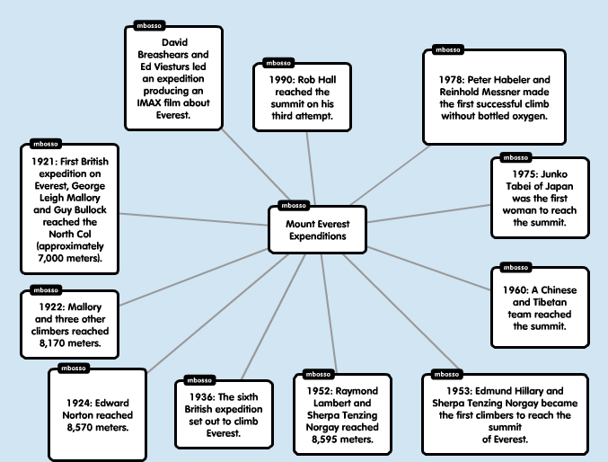
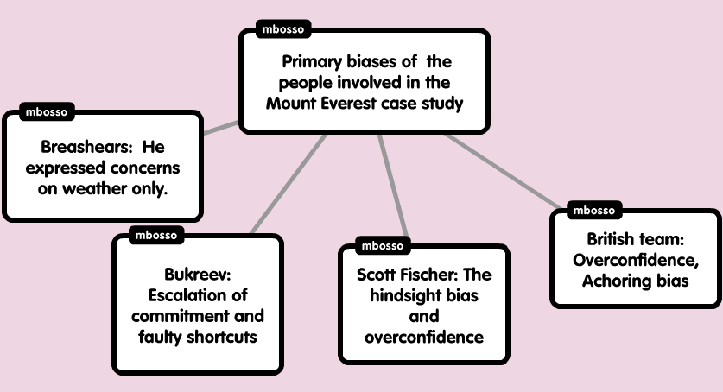 (Roberto & Carioggia, 2006)
Climbing Mount Everest has been adventurous dream of many people. The case study provides the most reflective information regarding the history of Everest. Notably, many people made attempts to reach the mountain’s summit but only a few were successful. As evident from the case, the majority of climbers succumbed to death while others set off their return journey before reaching the mountain peak (Roberto & Carioggia, 2006). In my conviction, the majority of mountain climbers suffered due to erroneousness and biases. For instance, some climbers relied on poorly estimated shortcuts and they failed to carry with them all the required supplements. The most pronounced biases in this case includes lack of concern to key elements of mountain climbing, escalation of commitments, the hindsight biases and anchoring bias (Shwarz, 2013). Moreover, some climbers were quite overconfident that they would make it to the mountain summit. It is worth to applaud the fact that mountain climbing is among the most interesting adventure. However, we must be reflective of the attached risks.

Bibliography
DeAngelis, L. "Leadership Lessons from teamwork." Leader to Leader, 2014: 19-25.
Lewis, A. "Creating a Culture of Accountability ." Leader to Leader, 2017: 12-16.
Meschiti, V. "The Power of Positioning: How Leadership Work unfolds in Team interactions." Leadership, 2018: 14-25.
Roberto, A., and Carioggia, M. "Mount Everest - 1996." Havard Business School, 2006: 1-19.
Shwarz, R. "How Well Does Your Leadership Team Really Work." Leader to Leader, 2013: 54-59.
Stevens, L. "Improving Teamwork, Staffing Adequacy, and Transparency to Reach High Reliability." Nurse Leader, 2014: 53-59.

Roberto, A., and Carioggia, M. "Mount Everest - 1996." Havard Business School, 2006: 1-19.
Lewis, A. "Creating a Culture of Accountability ." Leader to Leader, 2017: 12-16.
Roberto, A., and Carioggia, M. "Mount Everest - 1996." Havard Business School, 2006: 1-19.
Meschiti, V. "The Power of Positioning: How Leadership Work unfolds in Team interactions." Leadership, 2018: 14-25.
Shwarz, R. "How Well Does Your Leadership Team Really Work." Leader to Leader, 2013: 54-59.
Roberto, A., and Carioggia, M. "Mount Everest - 1996." Havard Business School, 2006: 1-19.
Roberto, A., and Carioggia, M. "Mount Everest - 1996." Havard Business School, 2006: 1-19.
DeAngelis, L. "Leadership Lessons from teamwork." Leader to Leader, 2014: 19-25.
Roberto, A., and Carioggia, M. "Mount Everest - 1996." Havard Business School, 2006: 1-19.
Roberto, A., and Carioggia, M. "Mount Everest - 1996." Havard Business School, 2006: 1-19.
DeAngelis, L. "Leadership Lessons from teamwork." Leader to Leader, 2014: 19-25.
Lewis, A. "Creating a Culture of Accountability ." Leader to Leader, 2017: 12-16.
DeAngelis, L. "Leadership Lessons from teamwork." Leader to Leader, 2014: 19-25
Roberto, A., and Carioggia, M. "Mount Everest - 1996." Havard Business School, 2006: 1-19.
Stevens, L. "Improving Teamwork, Staffing Adequacy, and Transparency to Reach High Reliability." Nurse Leader, 2014: 53-59.
Roberto, A., and Carioggia, M. "Mount Everest - 1996." Havard Business School, 2006: 1-19.
Roberto, A., and Carioggia, M. "Mount Everest - 1996." Havard Business School, 2006: 1-19.
Shwarz, R. "How Well Does Your Leadership Team Really Work." Leader to Leader, 2013: 54-59.

